**Suggestions are not showing**

**Solution:**

Open Eclipse IDE -> Go to windows -> Preferences ->Search for editor -> select editor below java -> click on advance below content assist -> check all boxes

OR

Paste this

**abcdefghijklmnopqrstuvwxyzABCDEFGHIJKLMNOPQRSTUVWXYZ**

**in Content Assist -> Auto activation triggers for Java for real time suggestions.**

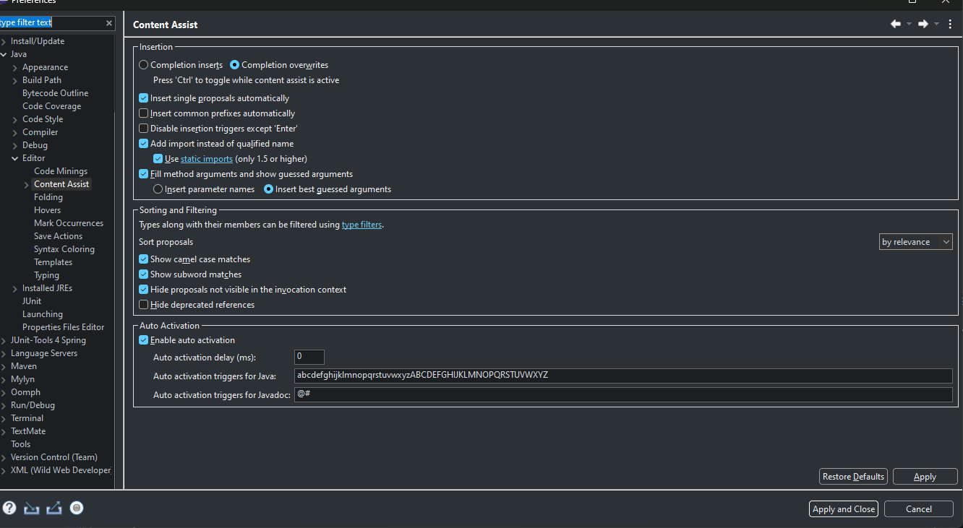

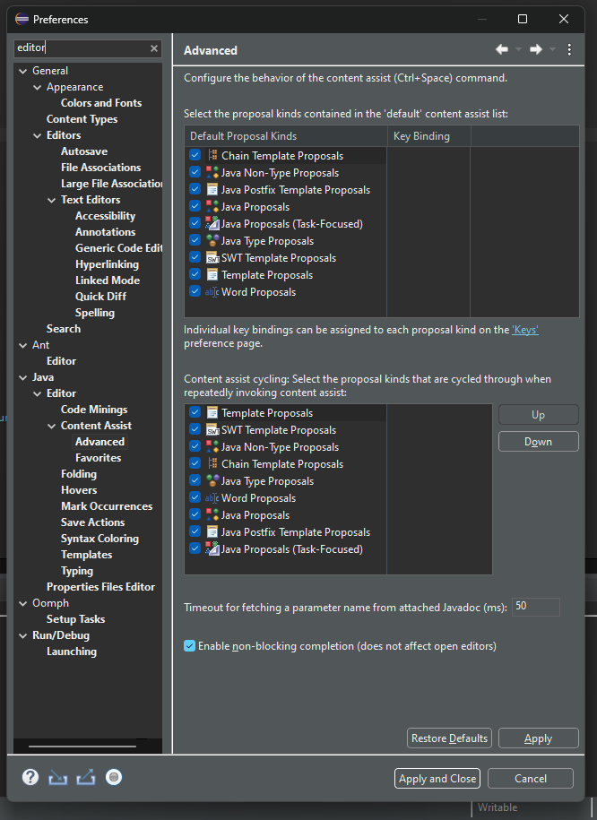

abcdefghijklmnopqrstuvwxyzABCDEFGHIJKLMNOPQRSTUVWXYZ